Employee Manager App

## Description:

This is a program to store a staff list of employees (with their different types) and volunteers…

Adding each one to a specific department to which they belong…

## Class Diagram:

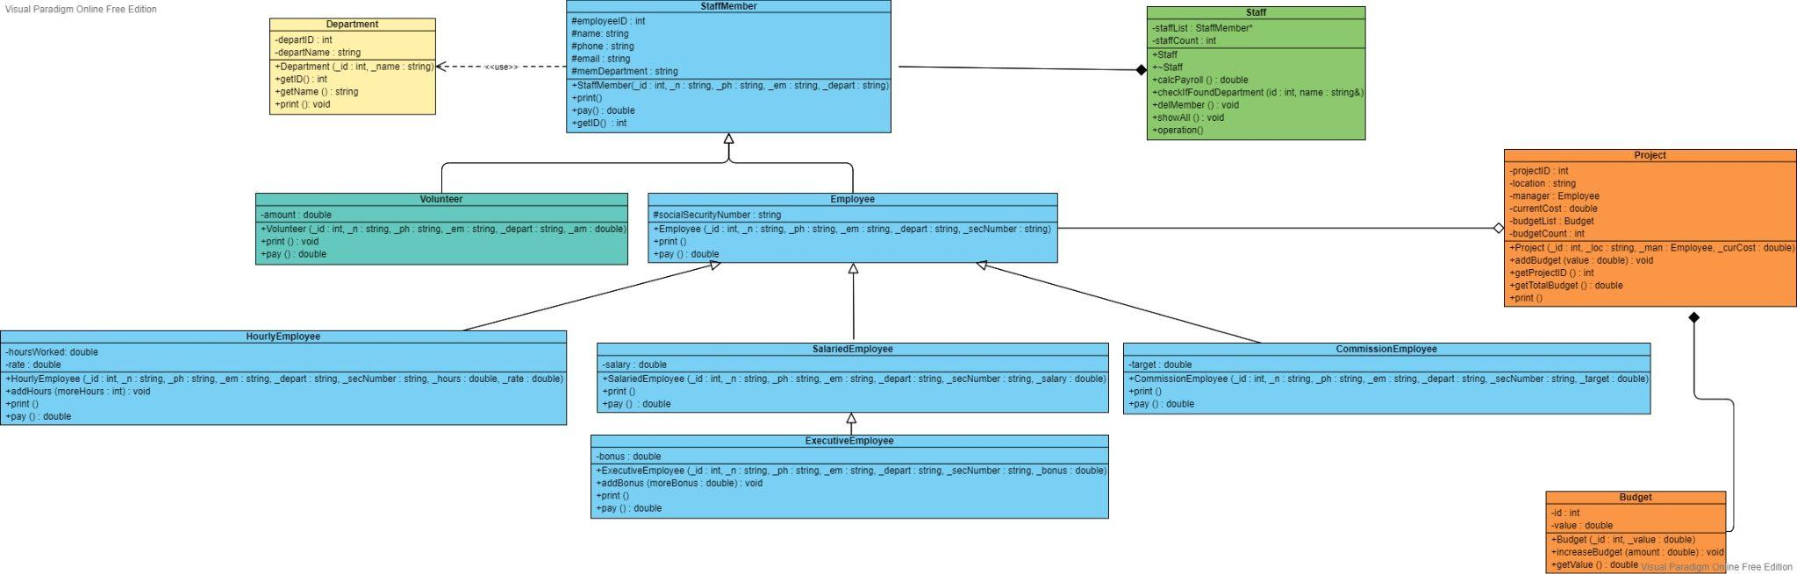

### Main Data Structure:

* + Mainly used is the “vector” to store the staff members and the budget list.

## Sample Execution Screenshots:

* + Main menu: 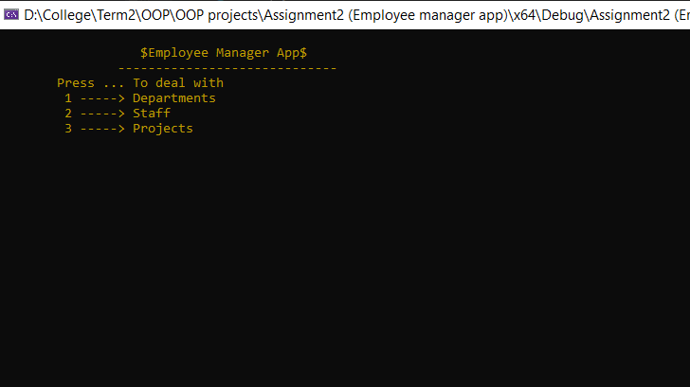
  + Adding a new department: 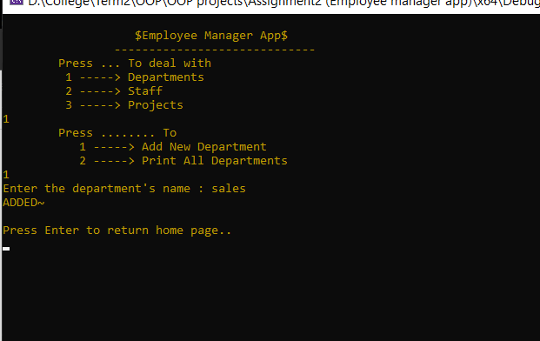
  + Print all departments: 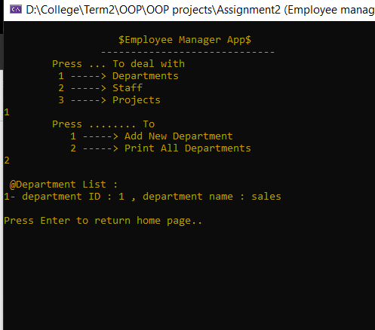
  + Adding a new member: 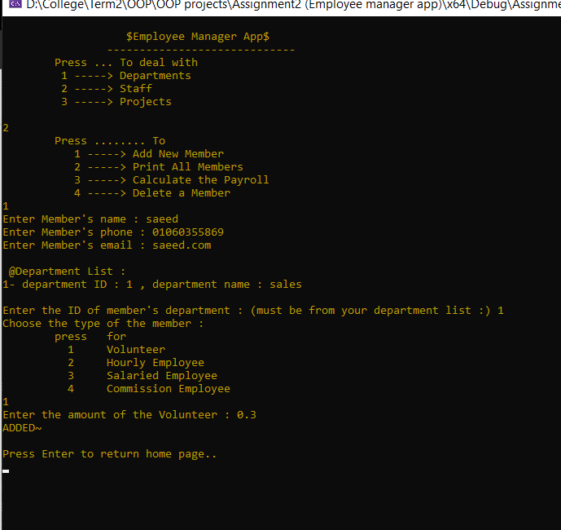
  + Print all members: 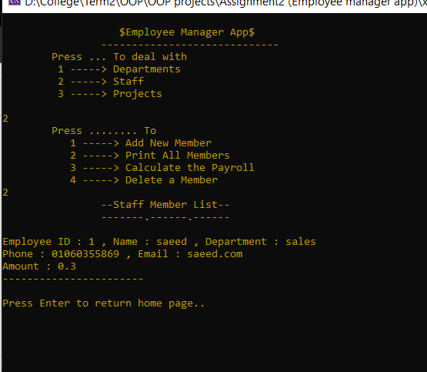
  + Calculating the payroll: 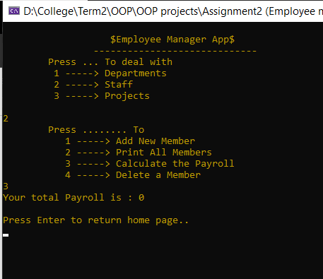
  + Delete a member: 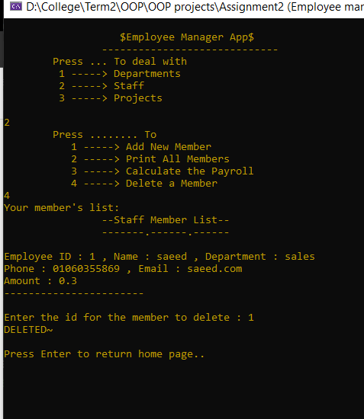
  + Adding a new project: 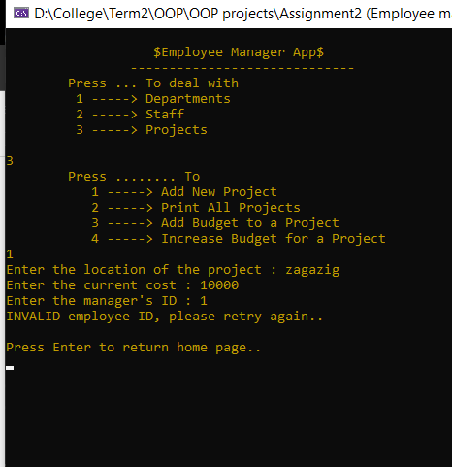
    - Invalid manager id, because it’s deleted soon..
  + Another adding with a valid id: 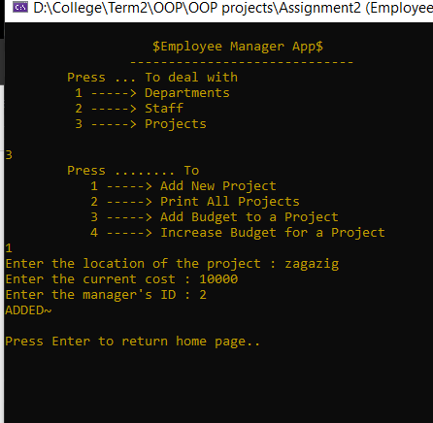
  + Print all projects: 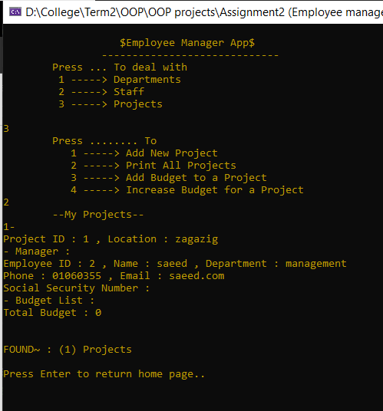
  + Add a budget to a project: 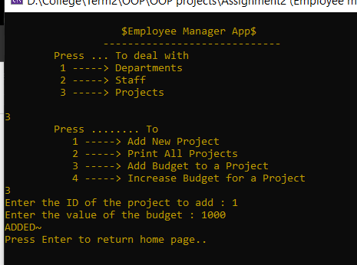
  + Increase an existing budget: 